Questions about the Tiger Flathead Dataset

Hello,

Some question came out from the dataset preliminary analysis.

**tiger flathead data_major zones.csv**

1. Is it possible to assume that the otolith radius at a certain age is the sum of all the previous otolith increments?
2. Radius should in theory be a summation of all increment measurements. In practice, this is not always the case. The radius is a straight line measurment from the core to thre edge, whilst the increment measurements may follow a curved path (tracking the growth axis) and also the measurement for the incomplete outer increment is not in the data.
3. Why does the same fish change sex several times?
4. Oops! Sorry about this. When I was putting together the spreadsheet for you I was copying across columns and got the wrong ‘sex’ one. I’ve attached a new spreadsheet with the correct sex data for each individual. The issue of fish ‘changing sex’ only occurs for those individuals which had an undefined sex ‘U’. I was mucking around trying to predict the sex of these fish using their growth history for our paper, but didn’t get very far (hence the stuff up). I omitted all fish with sex=’U’ from my analyses; but you’ve got the data here if sex-specific differences aren’t of interest to you. I had given you a copy of this modified ‘sexJM’ column instead of the correct ‘sex’ column (I used the correct sex data in our paper). Let me know if you have further queries here
5. I have noticed that "YearCap" have been copied into "Year" correspondant to Age 1 in each fish. The true year correspondant to Age 1 should be the previous of Age 2 (e.g. Age2 = 2002 => Age 1 = 2001). But in this way the Year relative to Age 1 would be equal to "YearClass" (shouldn't it be greater by 1?).

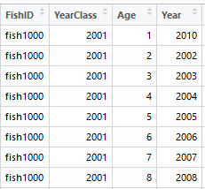

For exemple in fish1000 YearCap=2010, year relative to age 1 would be 2001, equal to Yearclass. Is it correct? Or should I consider Year(Age1) = 2002, Year(Age2) = 2003..... Year(Age8) = 2009?

Sorry, rushed spread-sheeting on my behalf again. For my paper I didn’t analyse data from the first year of growth because of issues around working out where the core actually is and because, depending on when a fish was spawned in relation to the designated birthdate, the first increment could represent 9 months or 14 months of growth. I added this first increment back in here as I thought it might be useful, but I stuffed up the Year. The ‘Year’ for the Age 1 increment should be Year at Age 2-1 (i.e. for fish1000, 2002-1=2001.

In regards to the Year and the YearClass for age 1: the first icnrement represents growth in the first year of an individuals life. This year started on the fish’s designated birthdate (for tiger flathead this is 1 January). In the case of fish1000, the first year of growth gets labelled the same as the YearClass (2001). When fish1000 turns one on 1 January 2002, the second increment (representing growth in this second year of life) gets labelled 2002 and so on. In a human example, if you’re birthday was 1 January you would turn a year older on that day and would maintain that age for the full following year until your next birtday (this year of your life would be defined by your birthday which here is the calenedar year).

In the second case sometimes YearCap=Year(MaxAge), as in fish2075.

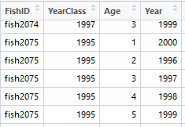

Again, appologies. The Year for Age=1 should be the same as the YearClass (which is the same as Age=2 Year-1 (as above). The error was in my excel formula which I hastily used to add this first increment measurement, not the rest of the data

**environmental data.csv**

1. Data referred to totalcatch in Newcastle region are expressed in kg? In this case totalcatch would be smaller than CPUE.
2. The Newcastle data comes from a State based fishery (as opposed to the Commonwealth fishery for all other fishing zones). They record their data differently, but in any case you don’t have Newcastle growth increments (data came from NSW Fisheries and I didn’t have permission to pass it on) so this might not be an issue?
3. In every year if CPUE is present, it is present totalcatch as well, except for 1984-Newcastle and 2011 Newcastle. Is it possible that totalcatch column is offset by one row in Newcastle?
4. The reason for the offset is that NSW Fisheries has a different reporting period to the Commonwealth fishery; I had to offset the data to ensure that they were comparable across zones.
5. Correlation between CPUE and totalcatch is low in all the regions but one. This is likely according to big variations in fishing effort through years, can you confirm that?
6. All zones have variable levels of fishing effort through time. This is partly because it is a multi-species fishery and trawlers may be switching between target species as they go? I’ve got a copy of the skipper log book data that documents shot-by-shot catches and hours trawled. You’ll definitely need to get AFMA permission to look at this as it contains commercial in confidence information, but once you have it I can pass my raw data on for you to interrogate further.

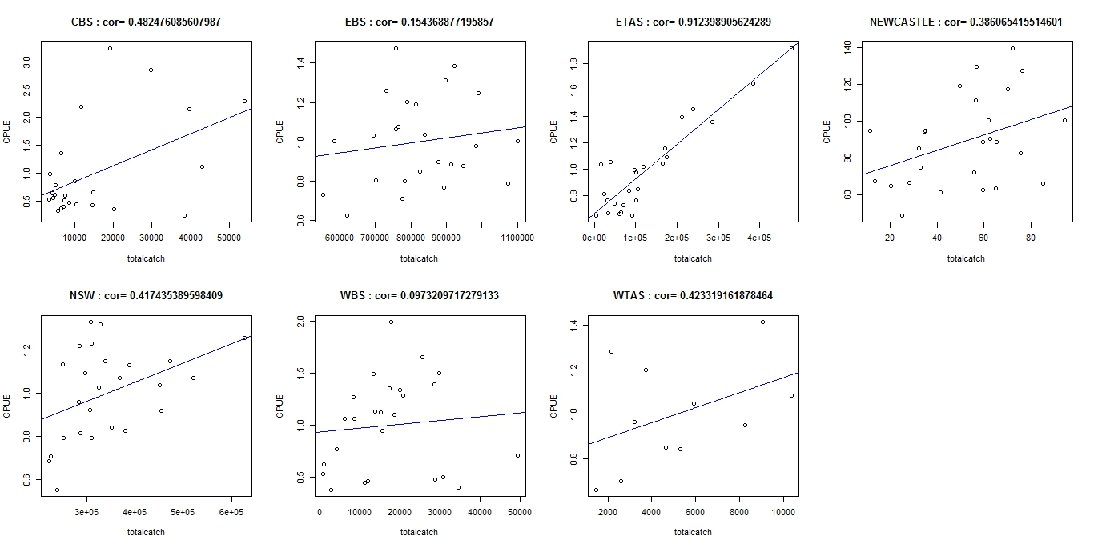

Thank you for the help.

Federico